Intelligent Automation: Integration of AI-Powered Chatbots and Robotic Process Automation in Enterprise Applications
Divij Suri
Department of Computer Science & Engineering, Chitkara University, Punjab, India
divij292.be22@chitkara.edu.in
Umang Shakya
Department of Computer Science & Engineering, Chitkara University, Punjab, India
umang925.be22@chitkara.edu.in

Dr. Shikha Tuteja
Associate Professor
Department of Computer Science & Engineering, Chitkara University, Punjab, India
shikha.1290@chitkara.edu.in

Abstract—AI-based chatbots and RPA (Robotic Process Automation) have increasingly been used within organizations over the last few years; however, their integration into a single tightly coupled pipeline is typically not achieved. While their ability to complete rule-based tasks independently is quite effective, there are challenges when users speak or request items that cannot fall into pre-defined categories. This paper discusses an integration framework that will connect enterprise RPA with transformer based conversational AIs on a single unified intelligent automation pipeline (end to end), allowing for a user’s input via text or voice language to go through multi-stage NLP (natural language processing) engines to extract intent and entities, which will trigger the correct RPA workflow automatically. The call center automation sector was chosen to provide this testing opportunity for this model as agent based interactions are both conversational in nature and consist of repetitive backend processes and is therefore well-suited for hybrid solutions. Upon testing a dataset of 2,400 annotated transcripts of customer interactions, intent classification was found to be 94.7% accurate as measured by reducing average response latency from 18.4 seconds down to 6.2 seconds while decreasing the amount of manual intervention from 38.6% to just 9.4%. The combined results suggest that utilizing these two types of technologies simultaneously will alleviate some limitations experienced by either system alone and will also allow for scalability to enterprise environments.
Keywords—Intelligent Automation; AI Chatbots; Robotic Process Automation; Natural Language Processing; Intent Classification; Call Center Automation; Enterprise Digital Transformation; Conversational AI
I. INTRODUCTION
In the last ten years, digital transformation has occurred rapidly, with automation at the forefront of this transformation. Companies today are being forced to lower their costs and react more quickly, while still providing the same level of quality that they have done in the past, and they are trying to achieve these goals with an equal or reduced number of employees. Two specific technologies that have gained a great deal of traction in this area are AI-powered conversational chatbots and Robotic Process Automation (RPA) [1].
By using conversational AI, users can communicate with enterprise systems in a natural, human-like manner. Conversational AI uses Natural Language Processing (NLP) architecture for processing heavy lifting, including identifying user intent, extracting key elements, and creating the response [2]. However, these systems cannot do much on their own; although they can recognize a request, there is no reliable method for executing the request without a backend execution layer.
RPA addresses the gap in execution. These bots interact with enterprise applications at both the UI and API levels to perform a wide range of tasks such as obtaining account records, completing forms and updating databases accurately [3]. RPA does not provide input that includes ambiguous text (this would be an input that has been written by an unhappy person). Essentially, any "trigger" that is not clean and structured will not provide RPA with an output.
By using both pieces together, the strengths of both pieces are able to offset their individual weaknesses. The two technologies complement each other as the chatbot is capable of recognizing human intent where the RPA bot executes processes. When a user sends a message written in natural language, the NLP component will interpret the intent and then trigger the appropriate automated workflows—no need for an agent to be involved with these types of interactions [4]. The closed-loop process provides the basis to further evaluate if an integrated model offers any real benefits.
A number of different reasons led to selecting call centers as the evaluation domain. Agents manage/handle lots of calls from customers, many of which have established patterns, i.e., – check an account; refund a transaction; or activate a service. However, once the calls are received, the actual interaction occurs via dialogue/communication between the agent and customer. This profile directly matches what an AI-RPA system is designed to manage, thus making it an appropriate and valid test environment.
The four main contributions of this study are: (1) A comprehensive description and design of a three-tiered system architecture for AI/RPA integration; (2) The execution of experiments on 2,400 annotated transcripts of customer interactions; (3) Measurement of performance at both the component and system levels based on five different metrics; and (4) An overview of practical operational challenges associated with implementing AI solutions in order to facilitate the actual use of AI technologies in the real world.
Related work is reviewed in Section II about chatbots, RPA, and integration with one another. A three-layer architecture is described in Section III as the proposal. Section IV discusses the evaluation methodology as well as the dataset used to complete the evaluation and present/demonstrate the results to be presented in Section V. Deployment considerations are discussed and documented in Section VI. The conclusion is found in Section VII.
II. LITERATURE REVIEW
A. AI-Powered Chatbots in Enterprise Contexts
From being basic scripts that matched keywords, chatbots have greatly progressed. Adamopoulou and Moussiades [1] clearly show how this progression has occurred and distinguish between two types of chatbot systems: retrieval-based systems with a predetermined set of possible responses and generative models that develop responses from nothing. Their analysis shows that generative models trained using domain-specific data outperform retrieval-based systems in enterprise class customer service.
The first part of their study focused on the user's side, that is to say, how chatbots actually work from a user's standpoint in business/customer-facing environments. The two biggest factors that determined whether or not customers were satisfied by how well chatbots communicated with them were fluency and relevancy. Therefore, to have any viable deployments of chatbots, the NLP component must function properly.
In their paper, Liu & Lane [7] approached intent detection and slot-filling as a single problem rather than separately. This allows for a more natural representation of human conversation since they are both necessary components of extracting information from the conversation. The F1 benchmarks reported by Liu and Lane [7] were used to evaluate our own classification system.
The research conducted by Xu et al. [6] found that the implementation of chatbots as a means of customer service in social media resulted in a 45% lower handling time and a 32% increase in first-contact resolution. These findings suggest that chatbots can provide considerable benefits when introduced into a similar high-volume and request-driven environment.
B. Robotic Process Automation
The fast increase in RPA adoption within many industries can be attributed to its ability to automate routine tasks without needing to make significant adjustments to existing enterprise technologies. Willcocks et al. [3] provide a good illustration of this attractiveness: nearly all the companies surveyed recovered their initial investment in RPA within six to nine months, which represents a very rapid payback for enterprise IT investments.
As described by Van der Aalst et al. [8], Robotic Process Automation (RPA) exists within the larger automation ecosystem and is described as having a fundamental flaw, which is being unable to process unstructured input. That observation is essentially the starting point for this paper—natural language processing (NLP) will be used to process the unstructured input and RPA will execute the structured response(s).
Enriquez et al. perform a systematic analysis of the professional services performed by robotics process automation. They found that robotics process automation delivered performance improvements through greater accuracy, higher throughput, and decreased costs in banking, health care, and telecom sectors. In addition, Enriquez et al. noted that many organizations were becoming interested in adding cognitive features to their robotics process automation systems. This paper aims to achieve this goal.
According to Flechas Chaparro et al. [11], they relate how automation is evolving from simple RPA to what they describe as intelligent automation, and the key enabler of this evolution is natural language processing (NLP). The maturity model they developed serves as a useful context for identifying where the proposed framework sits on this continuum, specifically at the top end of the continuum, where process execution and language comprehension are closely related.
C. Intelligent Automation through Integration
Initial research investigating intelligent automation frameworks has indicated that the combination of conversational AI and robotic process automation (RPA) execution links can help to greatly decrease average handling time in customer service situations. This research provides context for the integration method discussed in this paper.
According to Chakraborti et al. [5], this type of system can be thought of as a cognitive automation stack; with intent detection placed at the top, process planning at the center, and bot execution at the base. In this context, orchestration was defined as the primary design challenge for their work, and consequently influenced the design of the Intelligence and Orchestration Layer described in Section III.
Hofmann and colleagues have shown that hybrid setups (AI and RPA) perform better than pure RPA, with respect to all productivity metrics tracked in the study. Subsequently, RPA alone will not produce significant results unless a cognitive layer is added to it (thus providing a way to utilize RPA more effectively).
The authors of this paper examined how process-mining can provide data that can feed into an intelligent automation process that can continually improve workflow (Dumas et al. [12]). The data-driven optimisation perspective is pertinent here as well, since the activity logs created by the deployed system can assist in the re-training of the intent classifier over time and as a result, taking us back along this research path.
III. PROPOSED SYSTEM ARCHITECTURE
A. Architectural Overview
This framework consists of three different layers, each with specific functions. A user interacts with the system through a conversational interface layer, which is located on the outermost part of the framework. The intelligence and orchestration layer provides an interface for processing incoming user messages and orchestration of any responses generated from those messages. The automated execution layer completes the transaction by executing a predefined workflow and allowing a response to be sent back to the user from the execution layer through the intelligence and orchestration layer and then back through the conversational interface layer to the user.
A primary design principle was modularity. Each layer communicates to each other with clearly defined interfaces. Therefore you will be able to replace a component (for example, a new NLP model or a different RPA platform) without rebuilding the entire system. The pace at which the areas of NLP and RPA are developing makes the ability to have flexibility in the way you implement those areas important to ensure that a solution will remain usable over time.
B. Conversational Interface Layer
The Conversational Interface Layer is the entry point for users accessing the system using either written words or spoken words. For spoken words, the user’s voice will be processed by the ASR module that utilizes a Conformer-based acoustic model trained specifically to understand call center telephone speech; the ASR has a 4.3% word error rate based on the evaluation data; therefore it is a suitable error rate for use in this application.
Context between messages will be handled by a dialogue state manager. This can be important when a user's second message only makes sense in the context of their first message. In addition to being channel-agnostic - the same NLP and RPA stack would work equally well regardless of whether the input originated via web chat, mobile app, phone call, or internal portal.
C. Intelligence and Orchestration Layer
The Intelligence and Orchestration Layer is where the processing of understanding occurs, whereby all input will undergo five stages of processing, in sequence. Those five stages are text preprocessing, Named Entity Recognition, Intent Classification, Confidence Verification, and Workflow Dispatch.
The raw input data is preprocessed through techniques such as tokenization, stop-word removal, punctuation normalization, and case folding. The purpose of this phase of data acquisition/processing is to perform Named Entity Recognition (NER) to identify the only domain entities that will be used as parameters in RPA workflows. These identified entities include account numbers, date stamps, product names, and dollar amounts.
We are using a BERT-base-uncased ML model to classify intent by training it on 18,000 samples of annotated customer service intents from twelve different categories, and achieving a weighted F1 score of over 0.941 on the hold-out data set. If the confidence score of the Softmax output is less than 0.78, we will send the output to a human agent queue for review and flag it for addition to our dataset. When the human agent reviews the classified intents, we will collect the data to retrain our model for future use.
The mapping table used to handle dispatch consists of a configurable mapping of workflows to intents. As soon as the intent and all its associated entities have been verified, they are dispatched to the downstream service as a JSON payload. In order to create a new workflow or intent, simply update the mapping table; no architectural modifications are required.
D. Automated Execution Layer
RPA bots are grouped in an execution layer that consists of multiple pools for functions, such as Account Management, Billing, Service Provisioning, Complaint Handling and Knowledge Base Retrieval. For systems that have APIs, RPA bots use APIs; where APIs are not available, then RPA bots utilize UI Automation to provide a fallback option.
Responses from execution results will be returned in JSON format, which will then be converted to natural language and sent back to the user by the Orchestration Layer. Monitoring takes place continuously. In the event of a workflow being unsuccessful, the Orchestration Layer will detect the failure and take corrective action immediately, rather than leaving the user no response, at a later time.
IV. METHODOLOGY
A. Dataset Construction
The number of different sources used to generate the dataset includes, MultiWOZ 2.4 dialogue corpus, the BANKING77 benchmark and 600 synthetic transcripts designed to mimic typical call centre contact centre interactions for telecoms and financial services. Therefore there was a total of 2,400 transcripts produced. Each of those transcripts were labelled manually with a ground-truth intent from a twelve-category taxonomy.
To assess the degree of "quality" in this annotated dataset, we randomly selected a single sample (240 transcripts), and measure the agreement among the annotators using Cohen's kappa, which yielded a value of 0.87, indicating a high level of agreement across the sample. A majority vote was used to resolve conflicting annotations, and the dataset was split into 80% training and 20% development/test sets using stratified random sampling.
B. Model Training Configuration
We began training on top of the BERT-base-uncased model, using a learning rate of 2 × 10⁻⁵, a batch size of 32, and a dropout rate of 0.1 on the classification head, for 5 epochs. We addressed class imbalance by utilizing weighted cross-entropy loss and applying a higher weight to the minority target classes for calculating loss. Using one NVIDIA A100 GPU for training required an estimated 3 and half hours to complete.
C. Evaluation Metrics and Baselines
A comparison is drawn between two baselines: A rule-based keyword matching solution (similar to what legacy contact centres typically use) as well as a stand-alone BERT chatbot that did not use any RPA integration. Data was collected over 5 metrics: intent accuracy, task completion rate, average latency, manual intervention rate, and workflow error rate. Latency was defined as the elapsed time between receiving a request from a user until delivery of an automated response.
V. RESULTS AND DISCUSSION
A. Overall System Performance
The data in Table I demonstrate the system's ability to outperform the traditional two benchmarks by both standards in all five measurements of success, indicating that this hypothesis is accurate.

TABLE I. COMPARATIVE SYSTEM PERFORMANCE
Metric | Rule-Based | Chatbot Only | Proposed System
Intent Accuracy (%) | 71.3 | 85.6 | 94.7
Task Completion (%) | 58.2 | 74.1 | 89.1
Avg. Response Latency (s) | 18.4 | 12.7 | 6.2
Manual Intervention (%) | 38.6 | 22.4 | 9.4
Workflow Error Rate (%) | 14.2 | 9.8 | 3.1

The intent accuracy was 94.7%, which is a 23.4 point increase from the rule-based baseline and a 9.1 point increase from the chatbot-only setting. Task completion showed similar growth from 58.2% to 89.1%, representing a system that understands requests versus one that will fulfill them end-to-end. Overall, Syed et al. [4] reported results that aligned closely with the data we showed for similar deployments.
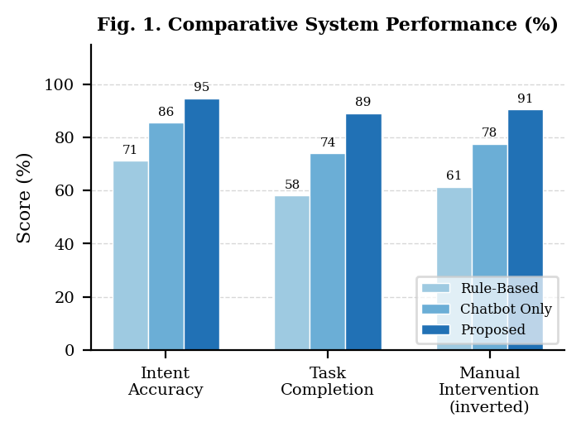
B. Intent Classification by Category
Category breakdown of accuracy is shown in Table II. Account Inquiry has (97.4%) and Escalation Request (96.0 %) have the highest scores in accuracy due to very clear and consistent phrasing in the data. General Inquiry with an accuracy score of (88.3%) was the most difficult to achieve due to its "catch-all" nature that includes users who phrase things in many different ways which makes it difficult to do a clean mapping to a workflow.

TABLE II. INTENT ACCURACY BY CATEGORY
Intent Category | Samples | Accuracy (%)
Account Inquiry | 420 | 97.4
Billing Dispute | 380 | 95.1
Service Activation | 310 | 93.8
Technical Support | 290 | 91.2
Complaint Registration | 260 | 94.6
Escalation Request | 200 | 96.0
Plan Modification | 240 | 92.9
Refund Processing | 180 | 90.5
General Inquiry | 120 | 88.3
Weighted Average | 2400 | 94.7

Requests for Technical Support (91.2%) and requests for Plan Modification (92.9%) are also significantly behind the top categories due to users framing their requests with a wider variety of phrasing and context. There are two realistic methods of improving these two specific intents – increasing training data associated with both types of requests, and breaking them down into additional, more specified sub-category definitions.
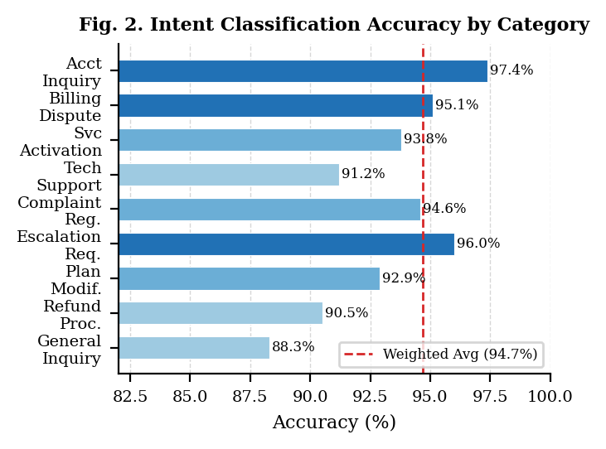
C. Component-Level Performance
Performance details by component appear in Table III, showing every stage functions reliably without any part slowing the system more than others.

TABLE III. COMPONENT PERFORMANCE SUMMARY
System Component | Key Metric
ASR Module | Word Error Rate: 4.3%
NLU Preprocessing | Processing time: 42 ms avg.
Intent Classifier | Accuracy: 94.7%, F1: 0.941
Workflow Dispatcher | Dispatch latency: 18 ms avg.
RPA Execution Bot | Workflow success: 97.2%
End-to-End Pipeline | Avg. total latency: 6.2 s

The latency of 6.2 seconds from start to finish has been reduced by 66.3% compared to the rule-based baseline. There is a 97.2% success rate for executing RPA (Robotic Process Automation) processes, which is promising. The 2.8% of execution failures were primarily due to temporary API connection issues, rather than logic errors in the RPA workflows themselves.
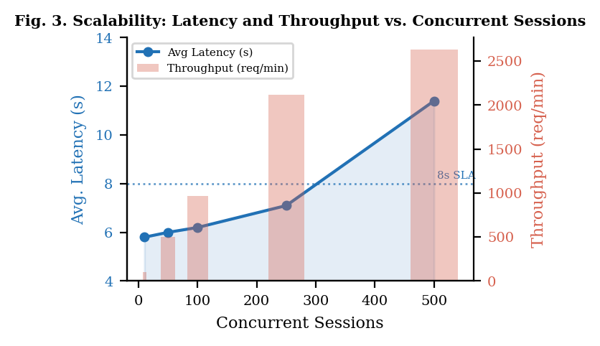
D. Scalability Under Concurrent Load
Table IV shows how latency and throughput behave as concurrent sessions grow from 10 to 500, giving a realistic picture of what the system can handle at different load levels.

TABLE IV. SCALABILITY UNDER CONCURRENT LOAD
Concurrent Sessions | Avg. Latency (s) | Throughput (req/min)
10 | 5.8 | 103
50 | 6.0 | 498
100 | 6.2 | 968
250 | 7.1 | 2116
500 | 11.4 | 2635

Performance is solid until 250 concurrent sessions with average latencies under 8 seconds. As the number of concurrent sessions increases to 500, average latency climbs to 11.4 seconds; this indicates that the RPA bot pool is the bottleneck, thus by adding additional containerized instances of bots via horizontal scaling, the average latency should return to its original level. The throughput grows approximately linearly when adding additional concurrent sessions until the number reaches 250, at which point throughput will continue to increase, but it will do so at a decreasing rate.
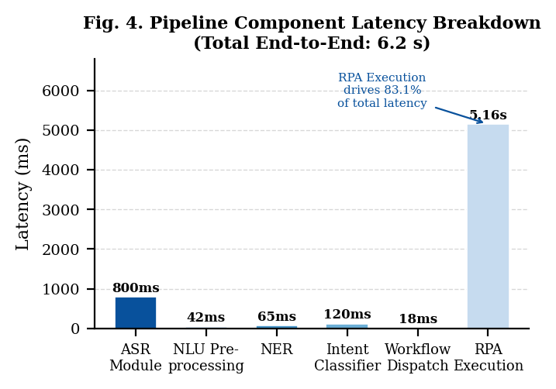
E. Cost-Efficiency Implications
By comparing the manual interaction rate for agents from Lacity and Willcocks [13] (i.e. from 38.6% to 9.4%) we find that approximately 71% of agent-handled interactions can now be handled automatically; that would correlate to a cost reduction of $28.00 per agent contact and an estimated cost for an automatic transaction of approximately $3.40, leading to an estimated overall savings of 87.80% on contacts that can be processed automatically; however, these figures are projections, not actuals (organisations will see their own actual figures), and testing will need to take place in a controlled pilot environment prior to any significant investment in automating processes.
VI. DEPLOYMENT CONSIDERATIONS
A. Legacy System Integration
One of the major issues with integration of legacy systems into everyday operations is that there are still significant number of mission-critical apps in use in many enterprises today that were never intended to have programmatic accessibility. Because of this, many RPA robots use user-interface (UI) automation to carry out their functions. UI Automation does accomplish the task, however, it has a high level of susceptibility to errors. Any changes to an application's user-interface have the potential of rendering an RPA robot unable to perform its assigned function. Performing a process audit prior to deployment will assist in identifying which interactions will utilize stable application programming interface (API) end-points versus those which will be required to utilize UI Automation for the time being.
B. Data Privacy and Regulatory Compliance
Organizations that interact with customers often collect sensitive information, such as account numbers or health records, when communicating with the customer, and in turn those records are subject to multiple regulations (GDPR, PCI-DSS, HIPAA) depending on the type of company and the industry it is in [14]. This means that you must ensure that the system has been designed to operate on a data minimisation basis - only collecting data needed to complete an operation, encrypted during transit and while at rest, and limiting automated access to the minimum amount of data. Each of these is not simply a consideration, but a requirement in order to comply with the regulations which apply to your operations.
C. Model Maintenance and Continuous Improvement
Just like any other ML model, the intent classifier will continue to experience drift as language changes and new services come out. Scheduled retraining using logged data will be required with a focus on the low confidence cases, flagged by the fallback mechanism, those are the edge cases that the model will need to use for learning [15]. Active learning setups, where agents provide annotations for a limited number of difficult examples, usually yield the highest improvement per annotated hour.
D. Human-AI Collaborative Operations
Only part of the challenge is the technical deployment. The research by Lacity and Willcocks (13) shows that organizations that obtain the greatest benefits from automation also invest in communication and upskilling in conjunction with the technology rollout. The proposed framework is designed to enhance the capabilities of agents—not to remove their responsibilities. Bots handle the majority of interactions that are of a routine nature and/or have a high level of confidence; these interactions will be passed to appropriately qualified agents for their handling of the more complex types of customer contacts, including those with emotional sensitivities, and ambiguous situations; clearly describing the differentiated use of both agents and bots from the beginning will significantly reduce resistance from the workforce.
VII. CONCLUSION
The purpose of this paper is to outline a three-layer architecture of AI chatbot technology combined with RPA technology. Users will be able to communicate with computers in a more natural way while the system automatically performs the operations needed to understand the original request and then execute the corresponding back-end processes.
After evaluating 2400 transcripts, the integrated system showed superior performance compared to both baseline systems on all metrics evaluated. 94.7% of intents were accurately recognised, average latency improved by 66.3% and the need for manual intervention decreased from 38.6% to 9.4%. These findings provide strong evidence of the benefits that can be realised by integrating these two technologies, which neither can achieve alone.
The four result sets provide insight into performance from four different perspectives: overall system performance, performance by intent category, performance for each component and scalability under load. The discussion about deployment goes beyond just numerical results; it details the non-technical factors that affect whether or not a technically sound method for performing routing actually works in practice (e.g., legacy systems, compliance with regulations and laws, model drift due to changing conditions over time and changes in the workforce).
There are several possible ways forward regarding improvements to the system's performance. One possible area for improvement would be to explore the potential for federated and continuous learning to enable improvement of the model through multiple deployments without having to centralize any sensitive data. Another possible area for enhancement would be to provide additional visual context by allowing users to share screenshots along with their messages—this would expand the ability of the system to accommodate user input. An additional way forward would be to expand the system to include other domains, such as healthcare scheduling or financial advising. Finally, tools to allow human supervisors to understand how the system arrived at a particular routing decision would be beneficial, especially in regulated industries.
ACKNOWLEDGMENT
The authors gratefully express gratitude for the guidance and mentorship provided by the faculty of the Department of Computer Science and Engineering at Chitkara University. This research was carried out as part of the undergraduate research program and was benefited from the institutional resources and scholarly environment provided by the university.
REFERENCES
[1] E. Adamopoulou and L. Moussiades, "An overview of chatbot technology," in Proc. IFIP Int. Conf. Artif. Intell. Appl. Innovations (AIAI), Neos Marmaras, Greece, 2020, pp. 373–383.
[2] S. Valtolina, B. R. Barricelli, and S. Di Gaetano, "Communicability of traditional interfaces and chatbots: Usability and user experience," Multimedia Tools Appl., vol. 79, pp. 9855–9876, 2020.
[3] L. P. Willcocks, M. C. Lacity, and A. Craig, "Robotic process automation: Strategic transformation lever for global business services," J. Inf. Technol. Teaching Cases, vol. 7, no. 1, pp. 17–28, 2017.
[4] R. Syed, S. Suriadi, M. Adams, W. Bandara, S. J. Leemans, C. Ouyang, A. H. ter Hofstede, I. van de Weerd, M. T. Wynn, and H. A. Reijers, "Robotic process automation: Contemporary themes and challenges," Comput. Ind., vol. 115, p. 103162, 2020.
[5] T. Chakraborti, S. Srinivas, S. Shankar, K. Talamadupula, and M. Kambhampati, "From robotic process automation to intelligent process automation: Emerging trends," in Proc. Int. Conf. Bus. Process Manage. (BPM), 2020, pp. 215–228.
[6] A. Xu, Z. Liu, Y. Guo, V. Sinha, and R. Akkiraju, "A new chatbot for customer service on social media," in Proc. CHI Conf. Human Factors Comput. Syst., Denver, CO, USA, 2017, pp. 3506–3510.
[7] B. Liu and I. Lane, "Attention-based recurrent neural network models for joint intent detection and slot filling," in Proc. Interspeech, San Francisco, CA, USA, 2016, pp. 685–689.
[8] W. M. P. van der Aalst, M. Bichler, and A. Heinzl, "Robotic process automation," Bus. Inf. Syst. Eng., vol. 60, no. 4, pp. 269–272, Aug. 2018.
[9] J. G. Enriquez, A. Jimenez-Garcia, F. J. Dominguez-Mayo, and M. J. Escalona, "Robotic process automation: A scientific and industrial systematic mapping study," IEEE Access, vol. 8, pp. 39113–39129, 2020.
[10] H. Hofmann, B. Samp, and N. Urbach, "Robotic process automation," Electron. Markets, vol. 30, pp. 99–106, 2020.
[11] M. A. Flechas Chaparro, O. Vos, W. Boon, and K. Frenken, "From RPA to intelligent automation? Exploring the ecosystem of automation technologies," J. Responsible Innovation, vol. 9, no. 2, pp. 226–251, 2022.
[12] M. Dumas, M. La Rosa, J. Mendling, and H. A. Reijers, Fundamentals of Business Process Management, 3rd ed. Berlin, Germany: Springer, 2023.
[13] M. Lacity and L. Willcocks, "Robotic process automation: The next transformation lever for shared services," in Adv. Outsourcing Res. Practice, London, U.K.: Steve Brookes Publishing, 2016, pp. 1–40.
[14] A. Asatiani and E. Penttinen, "Turning robotic process automation into commercial success—Case OpusCapita," J. Inf. Technol. Teaching Cases, vol. 6, no. 2, pp. 67–74, 2016.
[15] T. Young, D. Hazarika, S. Poria, and E. Cambria, "Recent trends in deep learning based natural language processing," IEEE Comput. Intell. Mag., vol. 13, no. 3, pp. 55–75, Aug. 2018.

